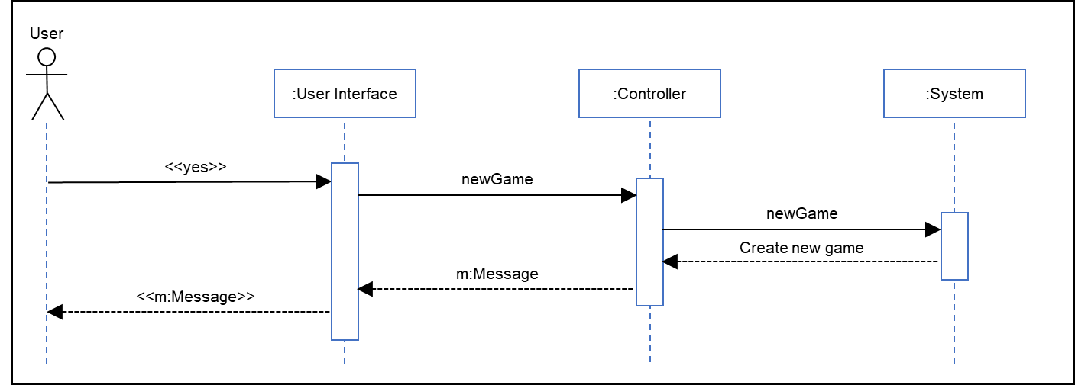**Analysis Sequence Diagram:**

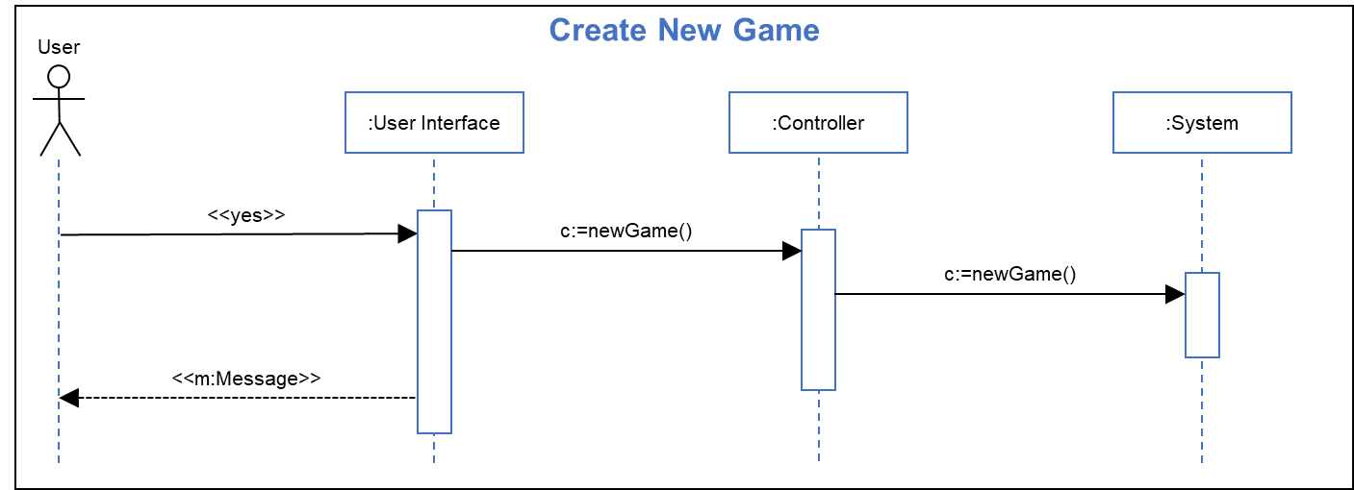**Design Sequence Diagram:**

**Sequence Step Description:**

**Title:** Create new game

**Actor(s):** User

**Precondition:** User has selected “yes” at prompt to create new game

**Outcome:** A new game is started at the start of level one.

|  |  |
| --- | --- |
| **User Actions** | **System Actions** |
| 3. User clicks UI “yes” button |  |
|  | 4.1. Game UI generates a new game message and sends it to the message controller. |
|  | 4.2 Message controller sends the new game call to the game controller. |
|  | 4.3 The game controller initializes a new game. |
|  | 5/6 The user interface displays the game view |
|  |  |
|  |  |

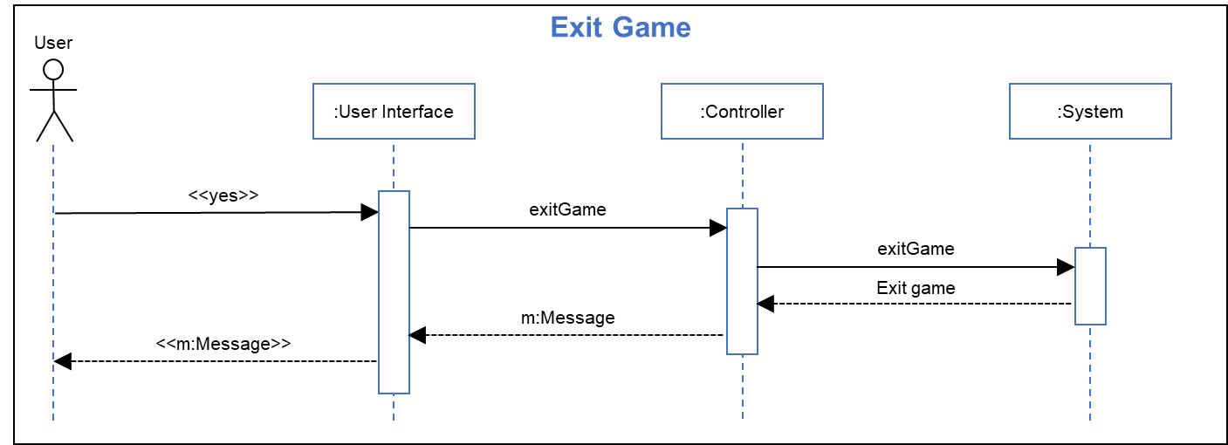**Analysis Sequence Diagram:**

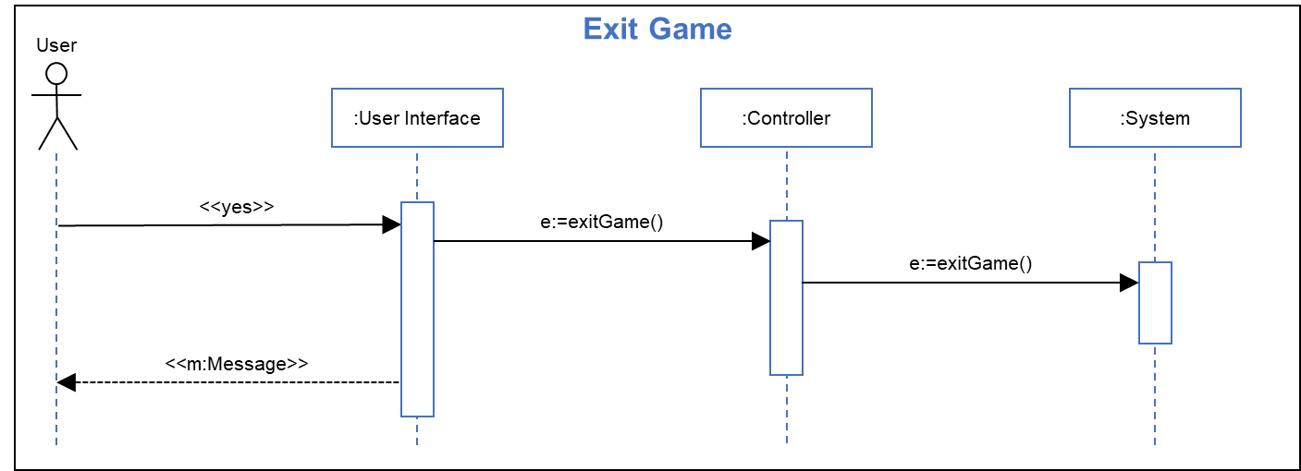**Design Sequence Diagram:**

**Sequence Step Description:**

**Title:** Exit game

**Actor(s):** User

**Precondition:** User has selected “yes” at prompt to exit game

**Outcome:** The current game session is ended and the title screen is shown

|  |  |
| --- | --- |
| **User Actions** | **System Actions** |
| 3. User clicks UI “yes” button |  |
|  | 4.1. Game UI generates an exit game message and sends it to the message controller. |
|  | 4.2 Message controller sends the exit game call to the game controller. |
|  | 4.3 The game controller ends the current game. |
|  | 5. The user interface displays the initial title screen. |
|  |  |
|  |  |

**Analysis Sequence Diagram:**

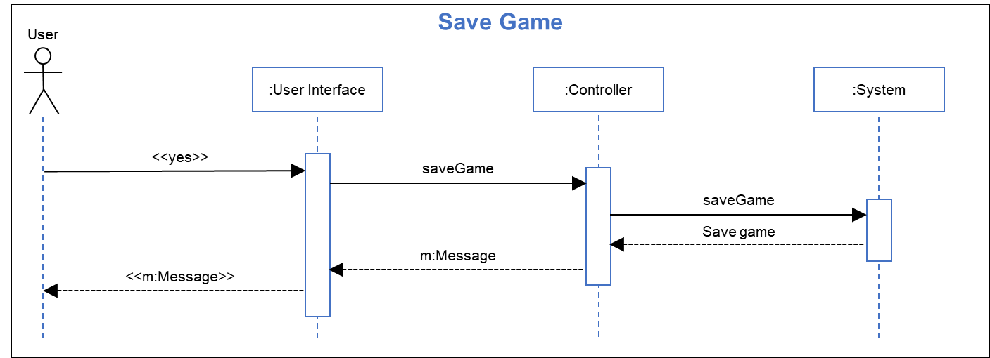

**Design Sequence Diagram:**

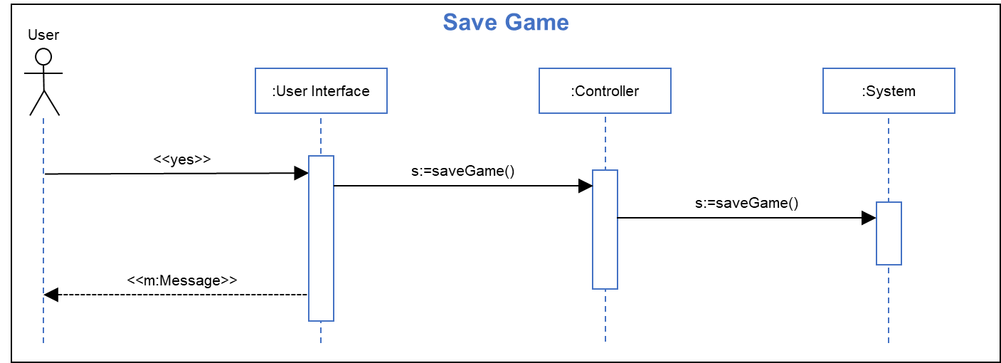

**Sequence Step Description:**

**Title:** Save game

**Actor(s):** User

**Precondition:** User has selected “yes” at prompt to save game

**Outcome:** The current game session state is saved and the game session is resumed.

|  |  |
| --- | --- |
| **User Actions** | **System Actions** |
| 3. User clicks UI “yes” button |  |
|  | 4.1. Game UI generates a save game message and sends it to the message controller. |
|  | 4.2 Message controller sends the save game call to the game controller. |
|  | 4.3 The game controller saves the current game state. |
|  | 5. The user interface returns to the game view. |
|  |  |
|  |  |

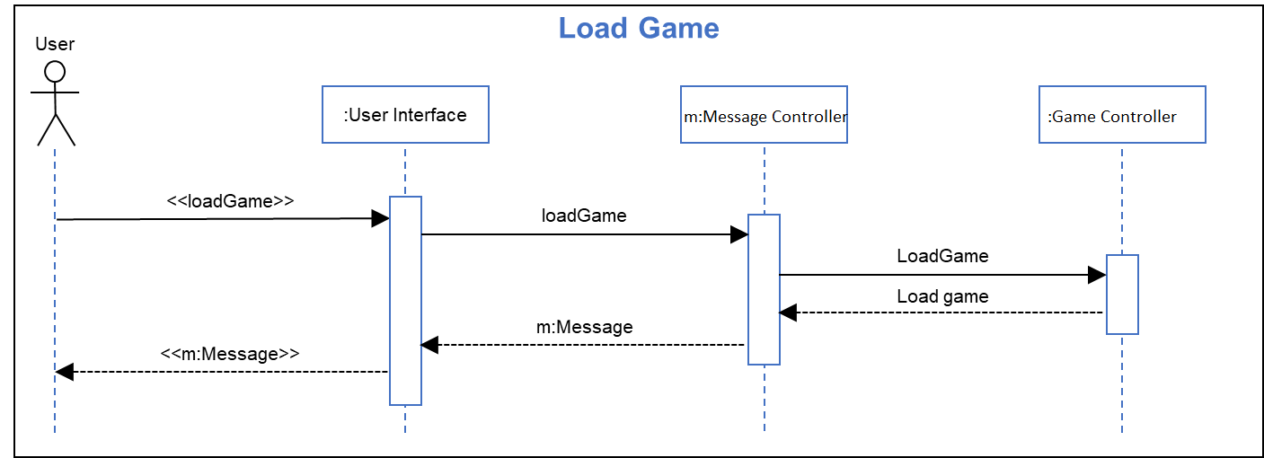**Analysis Sequence Diagram:**

**Design Sequence Diagram:**

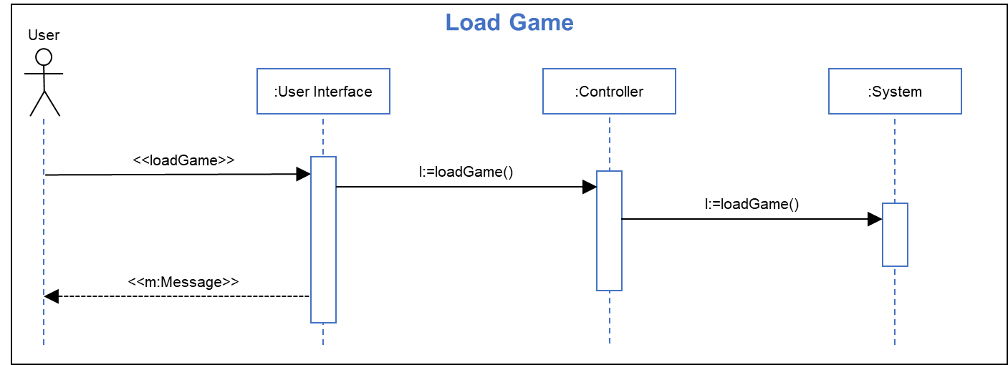

**Sequence Step Description:**

**Title:** Load game

**Actor(s):** User

**Precondition:** User has selected “yes” at prompt to load game

**Outcome:** The current game session state is saved and the game session is resumed.

|  |  |
| --- | --- |
| **User Actions** | **System Actions** |
| 3. User clicks UI “yes” button |  |
|  | 4.1. Game UI generates a load game message and sends it to the message controller. |
|  | 4.2 Message controller sends the load game call to the game controller. |
|  | 4.3 The game controller loads the game data saved previously. |
|  | 5/6. The user interface returns to the game view. |
|  |  |
|  |  |

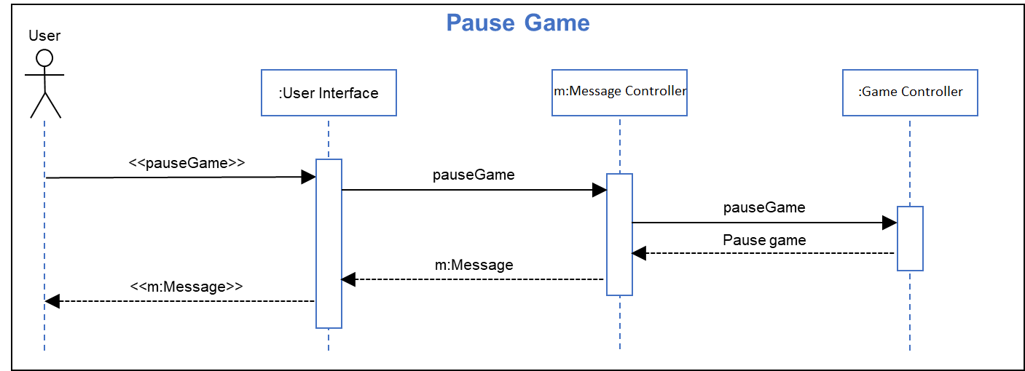**Analysis Sequence Diagram:**

**Design Sequence Diagram:**

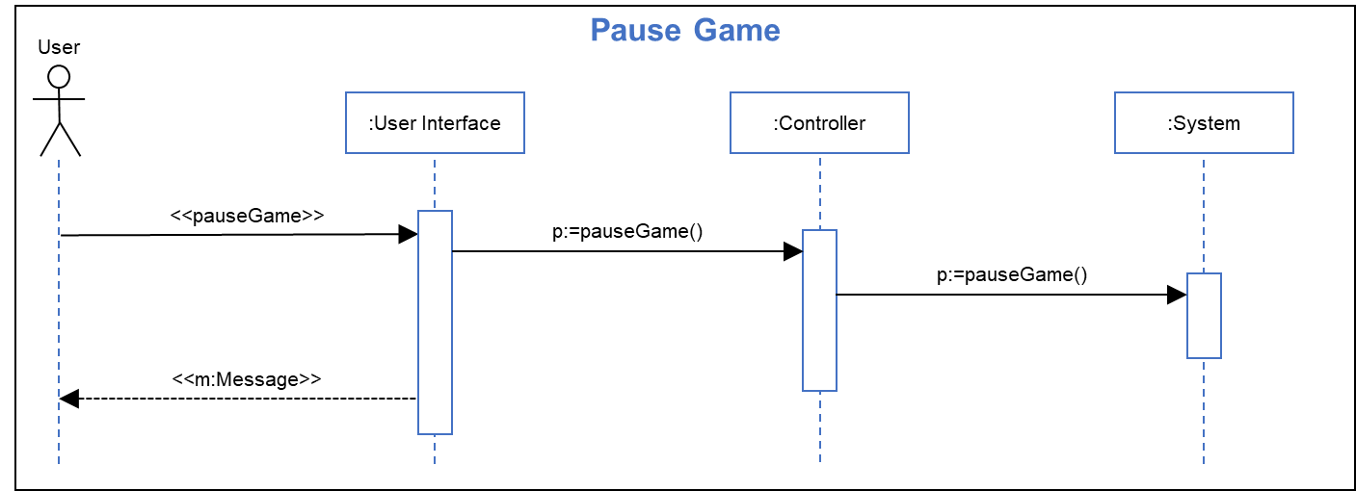

**Sequence Step Description:**

**Title:** Pause Game

**Actor(s):** User

**Precondition:** User is playing the game.

**Outcome:** Game is paused, user is notified that the game is paused.

|  |  |
| --- | --- |
| **User Actions** | **System Actions** |
| 1. User clicks UI pause button |  |
|  | 2.1. Game UI generates a pause game message and sends it to the message controller. |
|  | 2.2 Message controller sends the pause game call to the system controller. |
|  | 2.3 The system controller pauses the game. |
|  | 2.4 The user interface displays that the game is paused. |
|  |  |
|  |  |

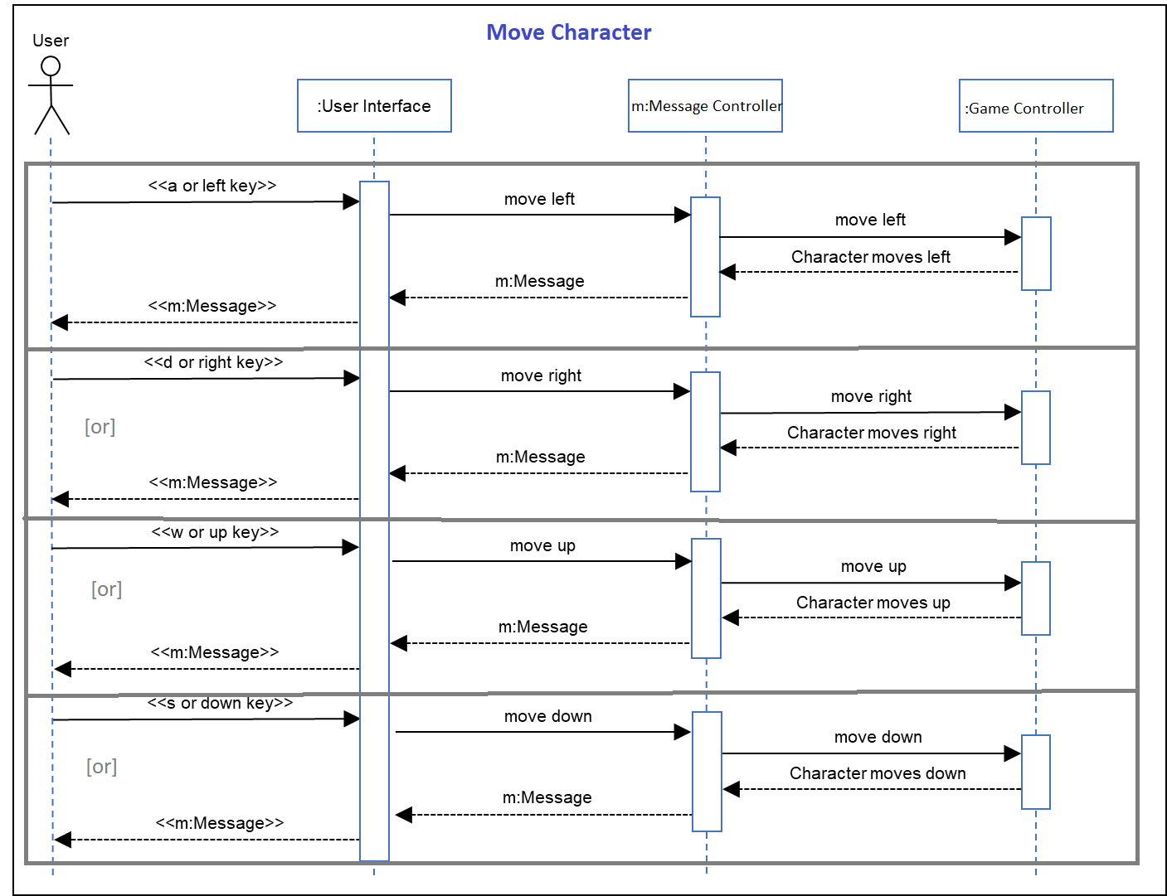**Analysis Sequence Diagram:**

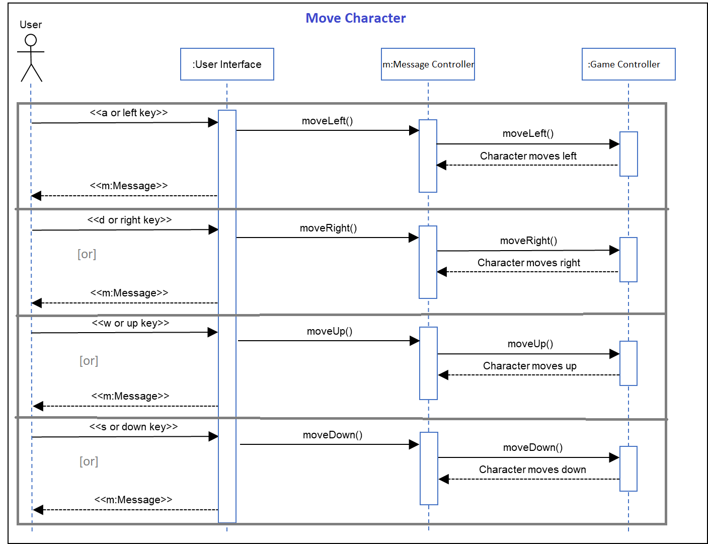**Design Sequence Diagram:**

**Sequence Step Description:**

**Title:** Move Character

**Actor(s):** User

**Precondition:** User is in an active play-session, game is not paused.

**Outcome:** The character moves in the direction desired by the player.

|  |  |
| --- | --- |
| **User Actions** | **System Actions** |
| 1. User presses movement key |  |
|  | 2.1. If player enters  (a) a-key, or  (b) left arrow key |
|  | 2.1.1. The UI sends a message to the message controller. |
|  | 2.1.2. Message controller sends a call to the game controller for the to character move left. |
|  | 2.1.3. The game controller moves the player left. |
|  | 2.2. If player enters  (a) d-key, or  (b) right arrow key |
|  | 2.2.1. The UI sends a message to the message controller. |
|  | 2.2.2. Message controller sends a call to the game controller for the to character move right. |
|  | 2.2.3. The game controller moves the player right. |
|  | 2.3. If player enters  (a) w-key, or  (b) up arrow key |
|  | 2.3.1. The UI sends a message to the message controller. |
|  | 2.3.2. Message controller sends a call to the game controller for the to character move up. |
|  | 2.3.3. The game controller moves the player up. (jump) |
|  | 2.4. If player enters  (a) s-key, or  (b) down arrow key |
|  | 2.4.1. The UI sends a message to the message controller. |
|  | 2.4.2. Message controller sends a call to the game controller for the to character move down. |
|  | 2.4.3. The game controller moves the player down. (crouch) |